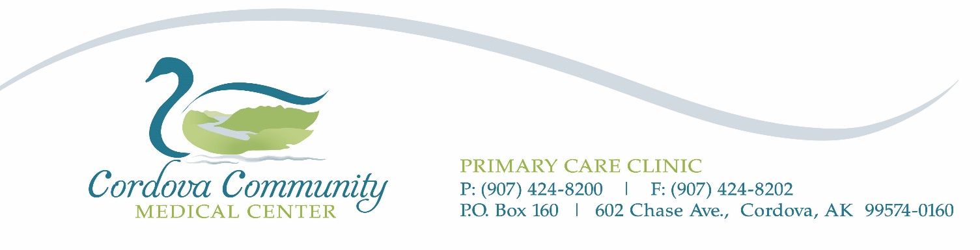
HEALTH FAIR LAB SELF-ORDERS
March 30 – May 6, 2022
Date: ____________________
Patient Name: ______________________________________________
Address: __________________________________________________
Date of Birth: ________________ Phone Number: ________________________
Fasting: |  | Yes |  | No

Test | Cost to Patient | Check labs ordered
LIPID PANEL 7600 | $20.00
Vitamin D 17306 | $60.00
Blood Type 7788 | $35.00

Results will be mailed to you. Only your health care provider can interpret laboratory results. RESULTS WILL NOT BE FORWARDED TO YOUR PROVIDER; it is your responsibility to retain a copy of your results and take them to your provider if you wish the results be reviewed or you have questions or concerns. Information on and interpretation of results will not be given over the phone.

Signature _____________________________________ Date ______________

