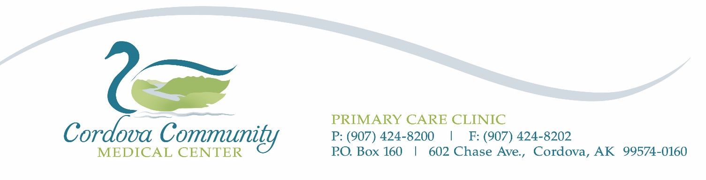
HEALTH FAIR LAB ORDERS
March 30 – May 6, 2022
Date: ____________________
Patient Name: ______________________________________________
Phone Number: _________________________
Date of Birth: ________________
Fasting: |  | Yes |  | No

Test |  |  |  |  | Cost to Patient |  | Check labs ordered
Package: CBC/CMP/LIPID PANEL 7600, 6399, 10231 |  |  |  |  | $40.00
A1C 496 |  |  |  |  | $35.00
PSA 5363 |  |  |  |  | $40.00
TSH 899 |  |  |  |  | $40.00
Vitamin D 17306 |  |  |  |  | $60.00
Blood Type 7788 |  |  |  |  | $35.00
Signature _____________________________________ Date ______________
Provider Name/NPI ________________________________________________

Fax Number for results ____________________________
Phone Number for questions ____________________________

